**Ideation Phase**

**Define the Problem Statements**

|  |  |
| --- | --- |
| Date | 01 july 2025 |
| Team ID | LTVIP2025TMID37541 |
| Project Name | Citizen AI – Intelligent Citizen Engagement Platform |
| Maximum Marks | 2 Marks |

**Customer Problem Statement Template:**

Create a problem statement to understand your customer's point of view. The Customer Problem Statement template helps you focus on what matters to create experiences people will love.

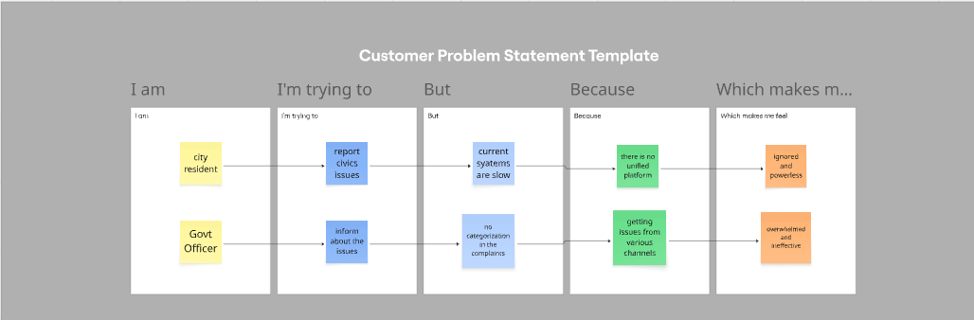A well-articulated customer problem statement allows you and your team to find the ideal solution for the challenges your customers face. Throughout the process, you’ll also be able to empathize with your customers, which helps you better understand how they perceive your product or service.

|  |  |  |  |  |  |
| --- | --- | --- | --- | --- | --- |
| **Problem Statement** | **I am (Customer)** | **I’m trying to** | **But** | **Because** | **Which makes me feel** |
| PS-1 | A citizen | Get answers about government services and benefits | Government websites are hard to navigate | They are complex, outdated, or unclear | Frustrated, confused |
| PS-2 | A concerned resident | Report civic issues like potholes or broken lights | I don’t know where or how to report them | There’s no central, simple reporting system | Ignored, unheard |